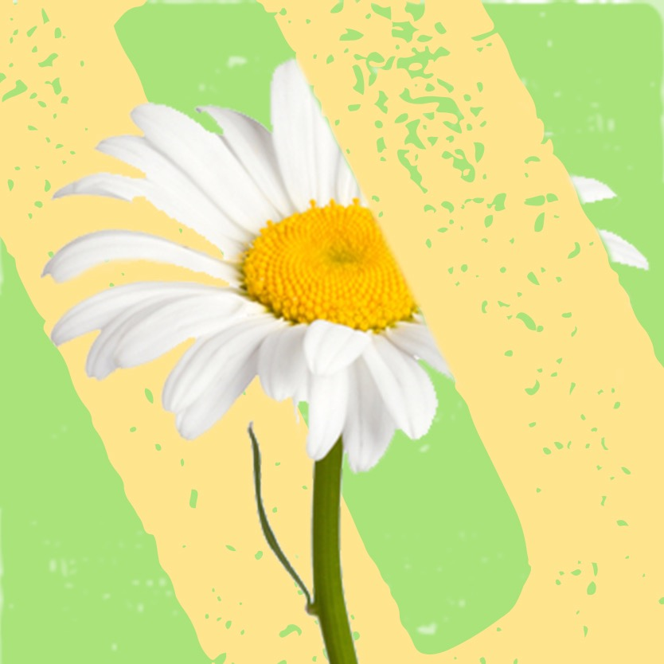

Pushing Up Daisies stock at Todmorden Library
Title | Author | Category
Lovely Old Rolly | Michael Rosen | Children’s Fiction
There’s something I’ve been dying to tell you | Linda Bellingham | Adult Non Fiction
Smoke gets in your eyes | Caitlin Doughty | Adult Non Fiction
Seeds | Ross Mackintosh ( local author) | Adult Graphic Novel
Heaven | Nicholas Allan | Children’s Fiction
Do not go gentle: poems for funerals | Neil,Astley | Adult Non Fiction
Let not the waves of the sea | Simon Stephenson | Adult Non fiction
Fault in our stars | John Green | Teen Fiction
I miss you: first look at death | Lesley Harker | Children’s Fiction
A monster calls | Patrick Ness | Children’s fiction
Being mortal : illness, medicine and what matters in the end | Atul Gawande | Adult Non Fiction
Suzanne’s diary for Nicholas | James Patterson | Adult Fiction
Goodbye Mog | Judith Kerr | Children’s Fiction
Saying goodbye to a pet | Nicola Edwards | Children’s non fiction
Saying Goodbye to a parent | Nicola Edwards | Children’s Non Fiction
Saying Goodbye to a brother or sister | Nicola Edwards | Children’s Non Fiction
Harry and Hopper | Margaret Wild | Children’s Fiction
Badgers parting gift | Susan Varley | Children’s Fiction
A Mothers love | Barbara Greene | Adult Non Fiction
Michael Rosen’s Sad Book | Michael Rosen | Children’s Fiction
It’s not because I want to die | Debbie Purdy | Adult Non Fiction
My Henry | Judith Kerr | Children’s Fiction
Lifeplanner guide to funerals and bereavement | Sam Weller | Adult Non Fiction
Before I die | Jenny Downham | Teen Fiction
The Sky is everywhere | Jandy Nelson | Teen Fiction
I’ll see myself out thank you | Colin Brewer | Adult Non Fiction
I miss you | Pat Thomas | Children’s Fiction
Year of magical thinking | Joan Didion | Adult Non Fiction
A grief Observed | C S Lewis | Adult Non fiction
Late Fragments | Kate Gross | Adult Non Fiction
Unbroken Trust | Jill Anderson | Adult Non Fiction
Huge bag of worries | Virginia Ironside | Children Fiction
My sister lives on the mantelpiece | Annabel Pitcher | Teen Fiction
Next to you | Gloria Hunniford | Adult Non Fiction

